- Go to SAIT.ca – Testing Services – Click “Book Your Exam” button. Login using your SAIT email address (@edu.sait.ca) and password.
- You will be directed to the exam registration screen to book your exam.
- Read the provided information at the beginning of the test registration.
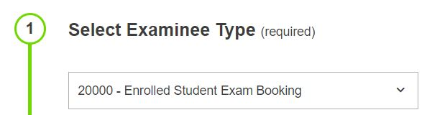
- Complete the submission form by following these steps:

- Examinee Type: Select "20000 – Enrolled Student Exam Booking" for all test bookings.

- Exam Category: Choose "21000 – SAIT Exam (Accommodated & Non-Accommodated)" for all exams.

- School: Select the school associated with your instructor or course. Contact your instructor if unsure.

- Academic Year: Choose the relevant year for your course (Should only be one option)

- Instructor: Pick your course instructor from the provided list. Contact them if not listed.

- Exam: Select the correct exam you want to book. Contact instructor if not listed.

- Accommodations(if applicable): Choose the accommodations you require; extended time and specific room accommodations will automatically be assigned.

- Available Date: Choose the date for your test. Confirm with your instructor if unsure.

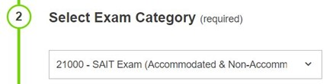

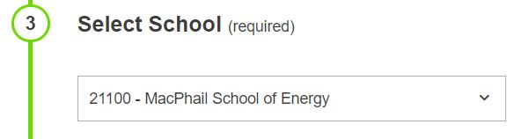

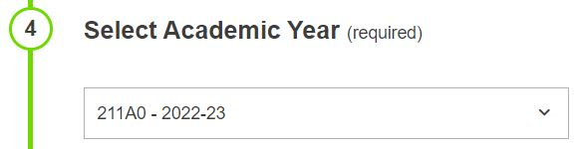

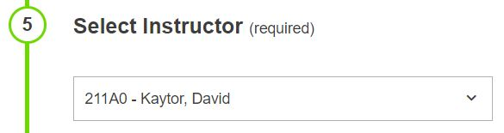

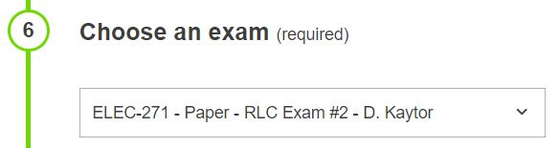

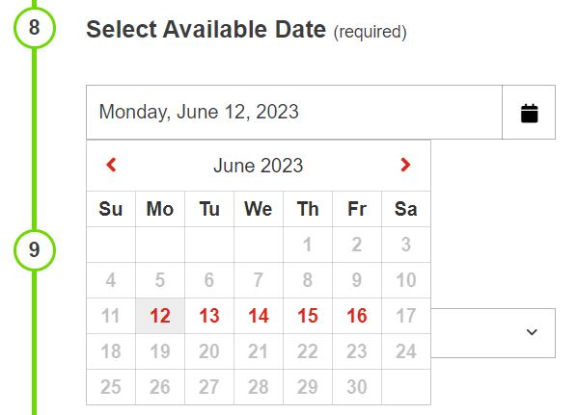

- Available Time: Select the test time from the drop-down menu. Contact your instructor if the desired time is not listed.

- Examinee Information: Verify that the displayed information is correct. Update if necessary.

- Exam Guidelines & Services: Read the exam guidelines and select "I agree" to proceed with the booking.

- Requested Information: Enter your student number, program name, and any additional information you want to provide. If you don't require accommodations for a specific test, mention it here.

- Complete Registration: Double-check the exam details and click "Complete Registration" to finish the process.

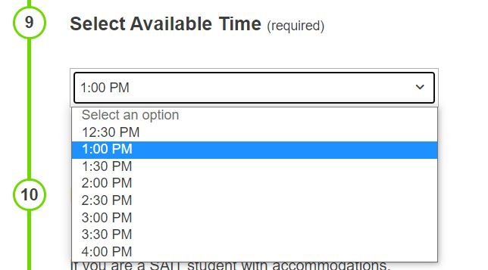

- After completing the exam registration, you should receive a confirmation email at the associated email address

Additional Notes:
- If you don't see your accommodations in Registerblast, contact the testing center.
- If you can't find your instructor's name or the exam you need to book, reach out to your instructor.
- Ensure to book your exams at least 96 hours before the exam date.

