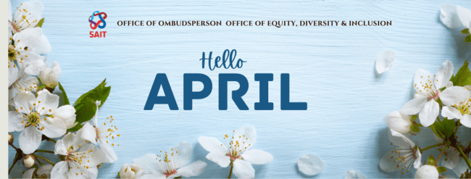

Ombudsperson Update
As a friendly reminder to all staff and faculty, Kamini Bernard, our Ombudsperson, is here as a resource for anyone within the SAIT community. If you or any of your students have questions, or concerns, or need guidance, she is ready to assist.
Individuals may self-book an appointment from the Ombudsperson’s webpage. The Ombudsperson also has scheduled convenient drop-in hours posted on the page. No appointment is needed during drop-in hours.

Drop in hours:
Date | Time
For April
Apr 3, 2024 | 10 am – 12 pm
Apr 4, 2024 | 11am – 1 pm
Apr 10, 2024 | 1 pm – 3 pm
Apr 11, 2024 | 1 pm – 3 pm
Apr 17, 2024 | 2 pm – 4 pm
Apr 24, 2024 | 2 pm – 4 pm
Apr 25, 2024 | 12pm – 2pm
For May
May 1, 2024 | 1 pm – 3 pm
May 2, 2024 | 9 am – 11 am
May 8, 2024 | 1 pm – 3 pm
May 9, 2024 | 9 am – 11 am
May 15, 2024 | 10 am – 12 pm
May 16, 2024 | 12 pm – 2 pm
May 22, 2024 | 2 pm – 4 pm
May 23, 2024 | 2 pm – 4 pm
May 29, 2024 | 9 am – 11 am
May 30, 2024 | 12 pm – 2 pm

Equity, Diversity & Inclusion Update
Workshop an EDI Idea
*NEW* Have an EDI-related idea you’d like to implement? Bring it to the EDI Advisory Council to workshop it with our in-house experts. The council meets monthly in-person, usually the third Thursday of each month, and is happy to offer insight and feedback. Email inclusion@sait.ca to start the process.

Equity, Diversity and Inclusion Moments
Hosting a meeting with colleagues? Start it off with an EDI moment — a brief educational talk on a topic related to equity, diversity and inclusion.
Pull inspiration from our collection of talking points below, or share your own diversity moment — perhaps a takeaway from training you’ve attended, or an action that helped a student or colleague feel included. Begin to recognize these moments in your day-to-day work and share them!
An effective diversity moment should:
✅ be quick to explain
✅ be positive in its impact
✅ spark discussion and learning

Looking for an EDI icebreaker to use as a team building activity? Try these options to bring an inclusion lens to your team dynamics. We recommend starting with “What’s in a Name?” and following up with ‘Get To Know You” later on. It is a good idea to set the expectation that team members share as much as they are comfortable.
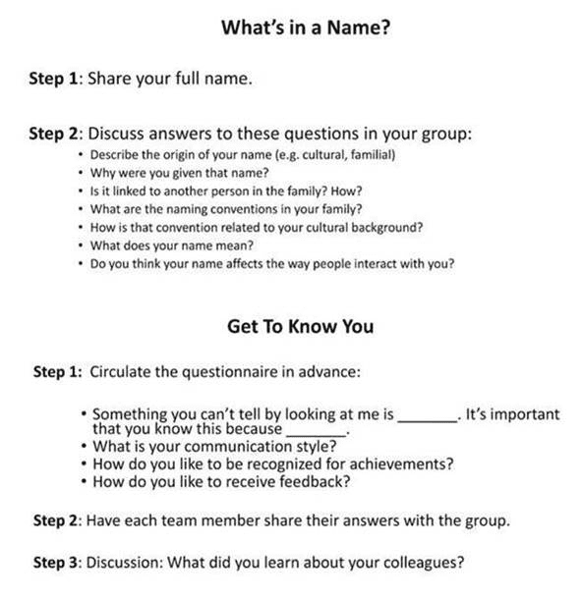

Launching the Indigenous Internship Leadership Program
Exciting collaboration between Vancouver Island University (VIU) and SAIT introduces the Indigenous Internship Leadership Program to support Indigenous post-secondary graduates in Alberta. This initiative aims to tackle employment barriers and boost career readiness in alignment with the Truth and Reconciliation Commission’s Calls to Action. With interest from numerous institutions and industry sponsors, the program is set to pave the way for valuable work experiences. Stay tuned for more updates as the program unfolds.
Inclusion Champion Series: Introducing the CAEI’s Perspectives Initiatives
The Centre for Applied Education Innovation is excited to announce the launch of the Perspectives Initiative, a transformative program designed to enrich our professional and personal lives through inclusivity and informed decision-making. This initiative aims to equip individuals with the tools they need to embrace diversity in their daily interactions and professional endeavors. Discover more about how you can participate and foster an environment of understanding and inclusion. Click here to learn more.
Women in Trades and Technology (WITT)
Starting April 2024, WITT will be housed within and led by Equity, Diversity and Inclusion. Stay tuned for more details on the future of the committee.

Employee Resource Groups
We have six active employee resource groups (ERGs) at SAIT. An ERG is a voluntary opportunity for individuals with similar interests to come together and advance the cause of an equity-deserving group. Find more information below:
- Black Empowerment and Excellence at SAIT
- EMBRACE
- Indigenous Employee Resource Group (email inclusion@sait.ca to join)
- Neurodiversity Alliance
- Pride at SAIT
- Women in Trades and Technology
ERGs add much value at an individual and institutional level—consider joining one today!
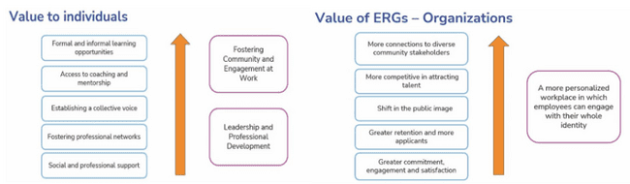

🌍 Enhance Your Skills: "PERS 148: Introduction to Effective Intercultural Communication"
Hello Everyone!
Exciting opportunity alert! The Office of EDI is offering PERS 148: Introduction to Effective Intercultural Communication. This course is a fantastic resource for enhancing our skills in navigating and understanding the complexities of intercultural interactions. It's an excellent chance for both personal development and professional growth – and it's free for all SAIT employees and students!
What You Need to Know:
📆 Duration: 6 weeks, online-synchronous
⏰ Weekly Commitment: 2 hours/week (1hr live session + 1hr reading/homework)
🏅 Bonus: Earn a micro-credential badge upon completion!
Future Sessions Starting: May 14th, 5-6pm | May 22nd, 12-1pm | July 3rd, 12-1pm
Ready to Register? Click HERE to secure your spot.
If you have any questions or need more details, please don't hesitate to reach out to our EDI team at inclusion@sait.ca.

New course for employees: Introduction to Equity, Diversity and Inclusion at SAIT
The Office of Equity, Diversity and Inclusion is happy to share a new learning experience available to SAIT employees. “Introduction to Equity, Diversity and Inclusion at SAIT” is a one-hour online, asynchronous course which introduces foundational principles, concepts and terms related to equity, diversity and inclusion (EDI). It is designed to be the starting point for employees on their individual EDI journeys. Learners will begin to grow their understanding of self and how to relate to others, as well as identify tangible ways to promote a healthy campus environment where everyone feels welcome, respected and empowered to succeed.
Learning Objectives:
- Identify the current components of equity, diversity, and inclusion at SAIT
- Describe the foundational principles, concepts, and terms of equity, diversity, and inclusion
- Develop self-awareness and ways to respectfully work across differences
- Recognize the professional development opportunities available to continue EDI learning at SAIT
New employees are encouraged to complete the course as part of their new hire Onboarding Checklist.
Current employees can complete the course by signing into PeopleNOW.

Family Campaign 2024
The results are in! 133 Inclusion Matters Shout Outs were sent raising $665 for the Inclusion Matters Fund. Thanks to everyone who acknowledged a colleague for their efforts to make SAIT a more inclusive place to work and study.

Traditional Powwow
Hope to see you at the upcoming spring Powwow hosted by the Office of Indigenous Engagement and Natoysopoyiis.

How to Support Ramadan?
Join us in honoring the observance of Ramadan, a time of reflection and renewal for our Muslim friends. We can show our support by learning about this significant month, respecting fasting practices, and offering a kind "Ramadan Mubarak" to those celebrating. Let's come together in the spirit of understanding and compassion.
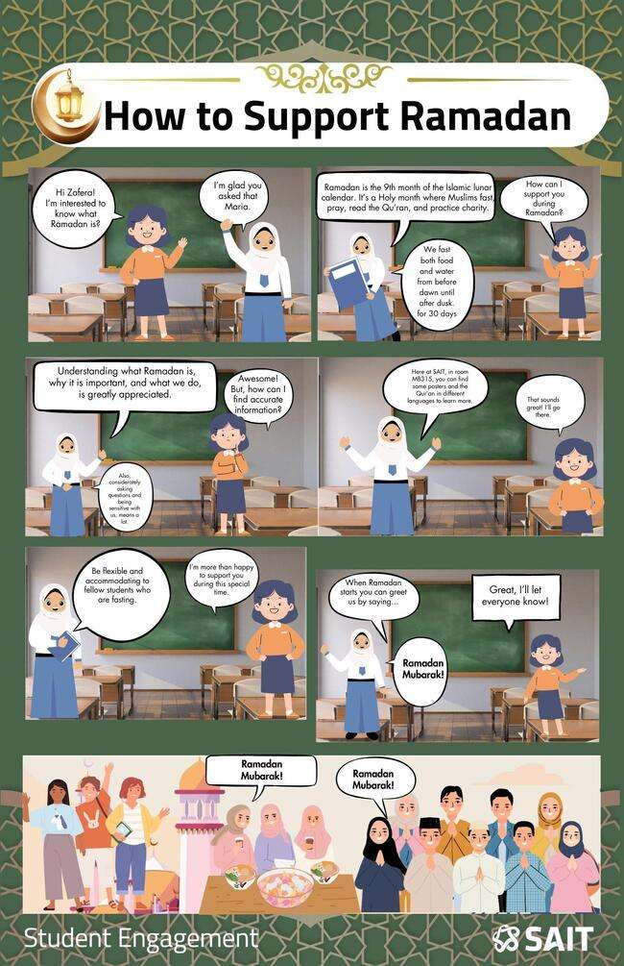
Eid al-Fitr Celebration
The Student Engagement Office at SAIT is thrilled to extend a cordial invitation to all for our Eid al-Fitr Celebration! An occasion of joy, reflection and a promise of memorable gathering for our diverse community.

